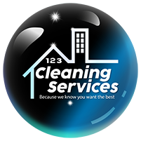

**Terms and Conditions - 123 Cleaning Services LLCZ**

**Last updated:**

By engaging the services of 123 Cleaning Services LLC, the customer agrees to the following.

terms and conditions:

**1. Scope of Service**

• All selected jobs will be performed within our technical and operational capabilities.

technical and operational capabilities.

• Any task or area not included in the contracted service will have an additional cost.

additional cost.

**2. Inspection and Warranty**

• 123 Cleaning Services LLC reserves the right to make general inspections to verify that the service

inspections in order to verify that the service has been performed correctly.

• Any non-conformity or claim must be notified within 24 hours after the completion of the service.

after the completion of the service. After that time, no claims will be accepted.

claims will not be accepted.

**3. Exclusions from the Service**

For safety and liability reasons, the following tasks are not performed:

• Cleaning of ceilings.

• Cleaning of high, non-accessible areas (over 6 feet high).

• Exterior or overhead window cleaning.

• Mold removal or deep grout cleaning.

• Moving furniture weighing more than 10 pounds.

• Cleaning of chandeliers or hanging lamps.

• Services on properties without access to water or electricity.

Translated with DeepL.com (free version)

**4. Valuables**

• The client is responsible for keeping money, valuables or fragile objects in a safe place before the service is

secure place prior to the provision of the service.

• In case of loss or damage, the claim must be demonstrated and notified within the same

24 hours after the completion of the service.